1.Write a Python program to implement the K-Nearest Neighbour(KNN) algorithm for a small dataset. Use Euclidean distance to find nearest neighbors and classify a test instance. Allow the user to input the value of K and display predicted class labels with accuracy.

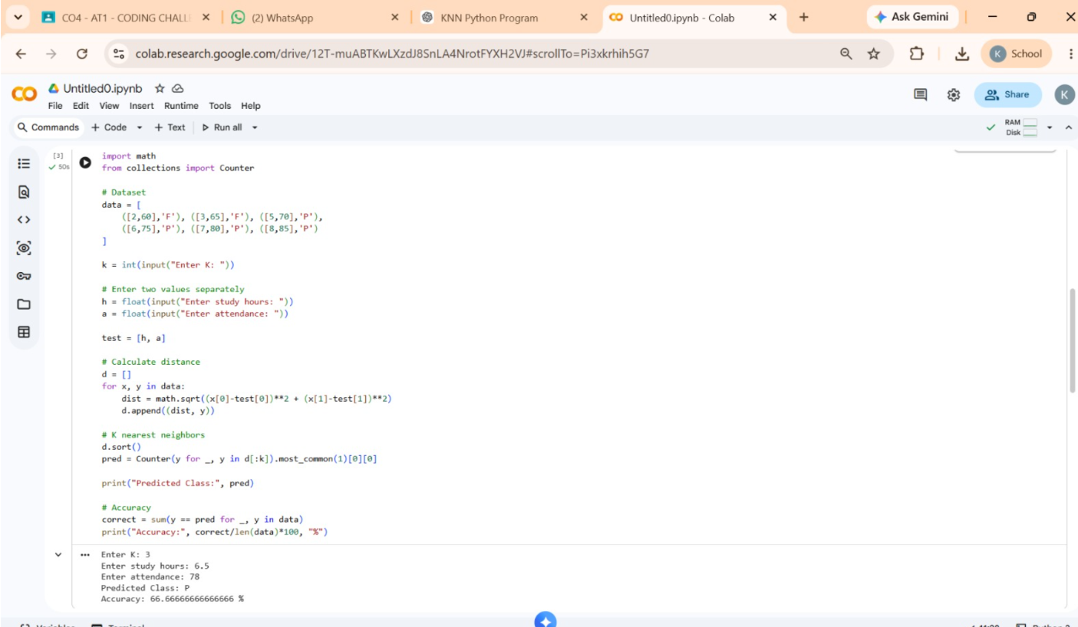

2.Write a Python program to implement Logistic Regression for binary classification. Train the model using gradient descent and predict outputs for test data. Display the sigmoid function output and classification results. Evaluate the model using accuracy and discuss how learning rate affects convergence and performance.
